MSI X299-RAIDER

1.a

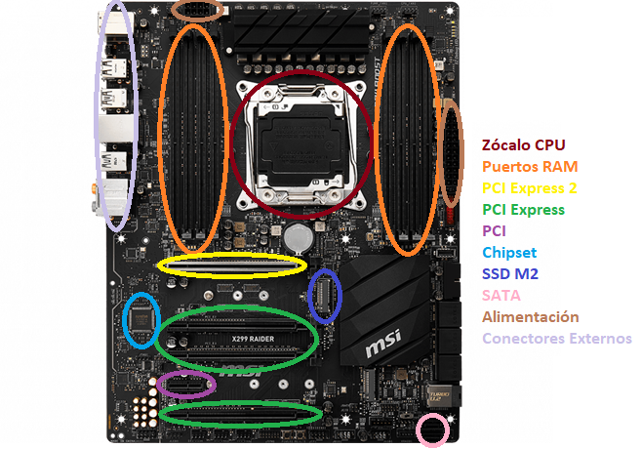

External Connections

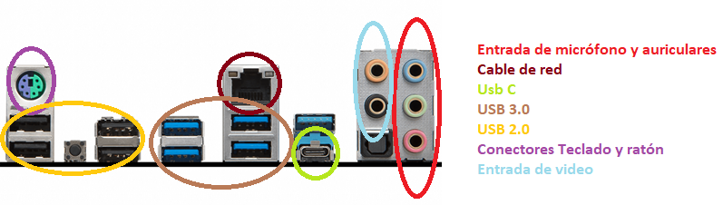

1.b ATX 12 in. x 9.6 in. (30.5 cm x 24.3 cm)

1.c Serie X Supports Intel® Core™ X-Series Processor Family for LGA2066 Socket

1.d DDR4 up to 128GB, Dual channel memory architecture with the CPU that supports up to 2-channels DDR4

1.e Intel® X299 Chipset, Supports RAID 0, RAID1, RAID 5 and RAID 10 for SATA storage devices

- Supports RAID 0 and RAID1 for M.2 PCIe storage devices

1.f

- 4 x PCIe 3.0 x16 slots

- Support x16/x16/x8 mode with the 44-lane CPU.*

- Support x16/x8/x4 modes with the 28-lane CPU.*

- Support x8/x8/x0, x8/x4/x4 modes with the 16-lane CPU.*

- 1 x PCIe 3.0 x1 slots

1.g

- 1 x 24-pin ATX main power connector

- 1 x 8-pin ATX 12V power connector

- 8 x SATA 6Gb/s connectors

- 2 x USB 2.0 connectors (supports additional 4 USB 2.0 ports)

- 2 x USB 3.1 Gen1 connectors (supports additional 4 USB 3.1 Gen1 ports)

- 1 x USB 3.1 Gen2 Type-C port

- 1 x 4-pin CPU fan connector

- 1 x 4-pin Water Pump connector

- 4 x 4-pin system fan connectors

- 2 x Front panel connectors

- 1 x Front panel audio connector

- 1 x LED extension connector

- 1 x TPM module connector

- 1 x Virtual RAID on CPU connector

- 1 x Thunderbolt add-on card connector

1.h Cortocircuitar jumper.

1.i

1.f Descargarlo de la web oficial e instalarlos.

2.

- USB 2.0: hasta 480 Mbps o **60 megabytes**

- USB 3.0 hasta 5 Gbps o **640 megabytes por segundo**

**- USB 3.1 hasta 10Gbps o 1280 megabytes por segundo**

**- eSATA tiene una calificación de 3 Gbps y 6 Gbps.**

**- Thunderbolt tiene una potencia de 10 Gbps por canal (x2). Thunderbolt 2 aumenta ese valor a 20 Gbps en un solo canal. Thunderbolt 3 duplica el ancho de banda nuevamente a 40 Gbps.**

**3.**



